
Sec 5.7 – Trigonometry & Regression
Piecewise Models Name:
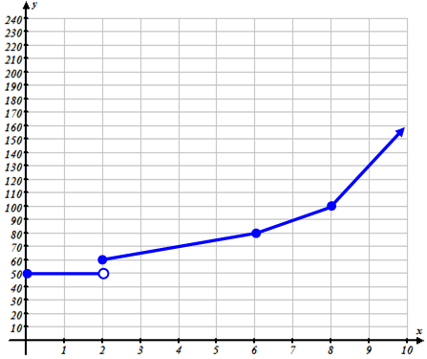

- A city water company charges homeowners based on how much water they use in thousands of gallons. The company progressively charges at a higher rate the more water that is used.
Water Usage (in thousands of gallons)
Cost of Water Bill (dollars)

  - Based on the graph at the right how much does the city charged when a home owner uses the following number of gallons of water:

1700 gallons of water costs .

2000 gallons of water costs .

7000 gallons of water costs .

  - Finish filling in the following piece-wise equation below that describes the chart based on the graph:

$y=\left\{\begin{matrix}\begin{matrix}\begin{matrix}50 & if 0≤x<2\end{matrix} \\ \begin{matrix}5x+50 & \end{matrix}\end{matrix} \\ \begin{matrix}\begin{matrix} & if 6≤x<8\end{matrix} \\ \begin{matrix}30x-140 & \end{matrix}\end{matrix}\end{matrix}\right.$

- Graph the following piece-wise graph
$$y=\left\{\begin{aligned}\begin{matrix}-x+1, x≤1 \\ \end{matrix} \\ 2x-3, &x≥1\end{aligned}\right.$$
- Determine the equation for the following piece-wise graph.

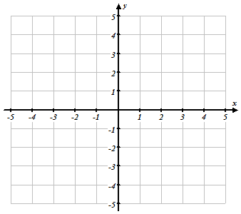

Student Worksheets Created by Matthew M. Winking at Phoenix High School SECTION 5-7 p.70

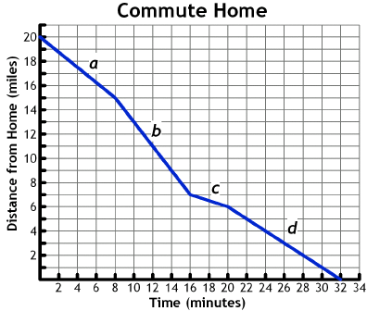
Mrs. Washington lives 20 miles from her office and drives her car to and from work every day. The graph below shows her distance from home over time as she drove home from work one day.

- Write a dependency statement expressing the relationship between the two variables, distance and time.

Segment | Slope | Equation of Line | Domain | Range
a
b
c
d

- What does the slope of a line segment represent in the context of this situation?

Student Worksheets Created by Matthew M. Winking at Phoenix High School SECTION 5-7 p.71

